# Institute of Information Technology

# Jahangirnagar University



LAB Exercise 3: To Understand and Analysis of the Functional Point.

**Software Engineering Lab Exercise Report Submitted By:**

|  |  |
| --- | --- |
| **Name** | **Class Roll** |
| Md. Shakil Hossain | 2023 |
| Mahabubur Rahman | 2024 |
| Nahidul Islam | 2028 |

Lab Date: 01/12/2022

Submission Date: 06/12/2022

**EXCERCISE NO. 3**

**AIM:** To Understand and Analysis of the Functional Point.

**REQUIREMENTS:**

**Hardware Interfaces**

* Pentium(R) 4 CPU 2.26 GHz, 128 MB RAM
* Screen resolution of at least 800 x 600 required for proper and complete viewing of screens. Higher resolution would not be a problem.
* CD ROM Driver

**Software Interfaces**

* Any window-based operating system (Windows 95/98/2000/XP/NT)
* WordPad or Microsoft Word

**THEORY:**

The overall objective is to determine the adjusted function point count. There are several steps necessary to accomplish this. While you may not understand the mechanics of the following steps. The actual sequence or order of steps is not necessary. Many counters will complete step 5 throughout the entire count gathering information as they go.

1. Determine the type of function point count

2. Determine the application boundary

3. Identify and rate transactional function types to determine their contribution to the unadjusted function point count.

4. Identify and rate data function types to determine their contribution to the unadjusted function point count.

5. Determine the value adjustment factor (VAF)

6. Calculate the adjusted function point count.

## OBJECTIVE:

The project objectives that will be achieved after completion of this project are discussed in this subchapter. The aims and objectives are as follows:

* Online book reading.
* A search column to search availability of books.
* Facility to download required book.
* Video tutorial for students.
* An Admin login page where admin can add books, videos or page sources
* Open link for Learning Websites

**Problem Analysis and Project Planning**

E-Library Management System is an application which refers to library systems which are generally small or medium in size. It is used by librarian to manage the library using a computerized system where he/she can add new books, videos and Page sources. Books and student maintenance modules are also included in this system which would keep track of the students using the library and also a detailed description about the books a library contains. With this computerized system there will be no loss of book record or member record which generally happens when a non computerized system is used. All these modules are able to help librarian to manage the library with more convenience and in a more efficient way as compared to library systems which are not computerized.

## RESOURCE:

**Software Requirement Analysis** (1) Module **Summary:**

* 1. **Administrator Module:**

Admin can produce accounts for students and make book lists. Admin can add new student and employee. Admin can update all information and can delete information.

* 1. **Student Module:** Student can create their own account providing id, registration number, session, batch, department.

**2.1 PROCEDURE:**

**(2)** **Functional and Non Functional  Requirements**

**(2.1) Functional Requirements:**

**(2.1.1) Login**

Integration with registration system:

* Student should provide password and ID
* System will the id and password validity
* System also provides Authentication .

**(2.1.2) Issue Book**

* System will provide details info like Book ID, Name,Author Name,Sudent id, Issue date and Return date.

**(2.1.3) Notice board**

System will automatically publish Opening and Closing time and different Notice.

**(2.1.4) Add New User**

* Student should provide Name, Session, Batch, Department.
* Provide Id,Password
* System will id and password validity

**(2.2) Non-Functional Requirements:**

**(2.2.1) Response Time**

a. Average response time shall be less than 2 seconds.

**(2.2.2) Throughput**

a. The system shall accommodate 1000 booked per minute.

**(2.2.3) Recovery Time**

a. In case of a system failure, the redundant system shall resume operations within 30 sec.

b. The average repair time shall be less than 1 hour.

**(2.2.4) Start-up/Shutdown Time**

a. The system shall be operational within 1 minute of starting up.

**(2.2.5) Capacity**

a. The system accommodates 4000 concurrent users.

**(2.2.6) Utilization of Resources**

a. The system shall store in the database no more than one million transactions.

b. If the database grows over this limit, the old transactions shall be backed up and deleted from the operational database.

**(2.2.7) Security**

a. Firewall Protection: The course management software system shall run inside a firewall.

b. Support different roles: The system shall support different roles for users, such as Instructors, Students, and administrative staff, the user logged in with the given role should only be allowed access consistent with that role. For example, a student shall only be allowed to see he/she grades not to modify them.

**(2.2.8) Reliability**

a. The system shall not be down more than 2 times in the year.

**(2.2.9) Scalability**

a. Scaling the system to a large number of users: large courses will have hundreds of students.

b. The system shall be able to handle the load for such courses, especially near assignment deadlines when many students can be expected to access the course management system.

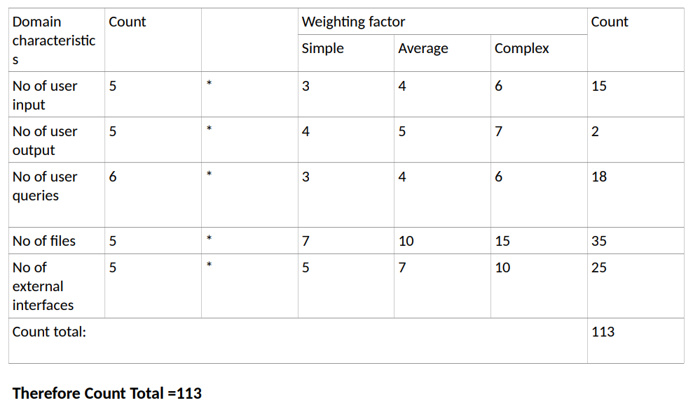

FP = count total *0.65 + 0.01 Σ ( Fi )

= 113 * (0.65 +0.01 * 25) where Σ ( Fi ) = 25

=113 *(0.65 + 0.25)

=113 * 0.9

= 101.7